**Project 1 - Creation of Single Page Website**

P.Akhila

**Project Title:**

**Responsive Single Page Portfolio Website – Akhila Paraselli**

**ABSTRACT:**

This project showcases a responsive **single-page portfolio website** developed for an individual, **Akhila Paraselli**, who is a frontend developer. The site includes structured sections such as an introduction, about me, contact information, and navigation elements. Built using only **HTML5, CSS3, and JavaScript**, the website offers a clean and interactive user experience. It demonstrates personal branding and serves as an online resume or professional introduction.

**OBJECTIVE:**

The main objective of this project is to create a visually appealing and mobile-responsive **portfolio website** that introduces Akhila Paraselli as a developer, presents her experience, educational background, and provides ways to contact her. The project focuses on a clean layout, smooth user navigation, and basic interactivity using front-end technologies.

**INTRODUCTION:**

A **single-page portfolio website** provides a complete overview of an individual on a single scrollable page. This project is designed for **Akhila Paraselli**, who aims to present her skills and experience as a frontend developer. The website contains key sections including a personal introduction (Home), About Me, Contact, and Social Profiles. The design adapts to different screen sizes using **responsive design** techniques and highlights basic interactivity through a **hamburger menu** on smaller screens.

**METHODOLOGY:**

**Technologies Used:**

* **HTML5** – For structuring the content (headings, sections, links).
* **CSS3** – For styling the layout, typography, and responsiveness.
* **JavaScript (Vanilla)** – For interactive navigation (hamburger menu toggle).
* **Font Awesome** – For adding social icons (via CDN).
* **Media Queries** – For mobile and tablet responsiveness.

**Step-by-Step Implementation:**

1. **Header and Navigation:**
   * Two navigation bars are included: one for desktop (.navbar) and one for mobile (.navbar-menu).
   * Used Flexbox to layout elements and media queries to switch visibility on different screen sizes.
   * Implemented a **hamburger menu** using JavaScript to toggle visibility on smaller screens.
2. **Home Section:**
   * Contains a welcoming message, name, role (Frontend Developer), brief intro, and buttons.
   * A **"Download CV"** button and a **"Contact Info"** button enhance interactivity.
3. **About Section:**
   * Presents experience, education, and an additional paragraph introducing the developer.
   * Used **flex layout** and reusable boxes to display experience and education visually.
4. **Contact Section:**
   * Displays email and LinkedIn profile with icons and labels.
   * Styled as a flex container with a border and spacing.
5. **Footer Section:**
   * Repeats navigation links and includes a copyright.
6. **JavaScript Functionality:**
   * A simple script toggles the hamburger menu:

js

CopyEdit

const hamburger = document.querySelector(".hamburger");

const menu_bar = document.querySelector(".navbar-menu .menu-bar");

hamburger.addEventListener("click", () => {

menu_bar.classList.toggle("show");

});

1. **Responsive Design:**
   * Used @media queries to:
     + Hide desktop navbar and show mobile version under 1024px.
     + Adjust text sizes and layout direction (column for mobile).
     + Ensure images and buttons scale properly.

**I have to create one html file,one script file,and 5 css files saperatly and link them**.

**Source code-1: index.html**

<!doctype html>

<html lang="en">

<head>

    <meta charset="utf-8">

    <meta name="viewport" content="width=device-width,initial-scale=1.0">

    <title>Akhila Paraselli | Portfolio</title>

    <link

     rel="stylesheet"

     href="https://cdnjs.cloudflare.com/ajax/libs/font-awesome/6.7.2/css/all.min.css"

     integrity="sha512-Evv84Mr4kqVGRNSgIGL/F/aIDqQb7xQ2vcrdIwxfjThSH8CSR7PBEakCr51Ck+w+/U6swU2Im1vVX0SVk9ABhg=="

     crossorigin="anonymous"

     referrerpolicy="no-referrer"

     />

    <link href="stylesheet.css" rel="stylesheet">

    <link href="sec1.css" rel="stylesheet">

    <link href="sec2.css" rel="stylesheet">

    <link href="sec3.css" rel="stylesheet">

    <link href="sec4.css" rel="stylesheet">

</head>

<body>

    <!--navbar-->

    <nav class="navbar">

        <div class="logo">Akhila Paraselli</div>

        <ul class="menu-bar">

            <li><a href="#about">About</a></li>

            <li><a href="#contact">Contact</a></li>

        </ul>

    </nav>

    <!--navbar-->

    <nav class="navbar-menu">

        <div class="logo">Akhila Paraselli</div>

        <div class="hamburger"><i class="fa-solid fa-bars"></i></div>

        <ul class="menu-bar">

            <li><a href="#about">About></a></li?

            <li><a href="#contact">Contact</a></li>

        </ul>

    </nav>

    <!--navbar-->

    <section class="sec1">

      <div class="sec-1-1"><img src="C:\Users\Paraselli Akhila\Downloads\std.webp"/></div>

      <div class="sec-1-2">

        <span class="sec-1-2-1">Hello,I'm</span>

        <h1>Akhila</h1>

        <span class="sec-1-2-3">Frontend Devloper</span>

        <p>

            Hi, I'm Akhila from Srikakulam district.

            This is a simple portfolio to introduce myself.

            I'm a Frontend Developer and also  knowledge of Python as well.

            I work well with HTML, CSS, and JavaScript to build user-friendly web interfaces.

        </p>

        <div class="btns">

            <a href="C:\Users\Paraselli Akhila\Downloads\Akhila  _ Portfolio.pdf"/><button>Download CV</button></a>

            <button onclick="window.location.href='tel:+918341166041'">Contact Info</button>

        </div>

        <div class="social">

            <img src="C:\Users\Paraselli Akhila\Downloads\GitHub.png"/>

            <img src="C:\Users\Paraselli Akhila\Downloads\linkedin.jpg"/>

        </div>

      </div>

    </section>

    <!--section 2 / About-->

    <section class="sec2" id="about">

        <div class="sec-2-1">

            <snap>Get to Know more</snap>

            <h1>About Me</h1>

        </div>

        <div class="sec-2-2">

            <div class="sec-2-2-1">

                <img src="C:\Users\Paraselli Akhila\Downloads\std.webp"/>

            </div>

            <div class="sec-2-2-2">

                <div class="sec-2-2-2-1">

                    <div class="box">

                      <img src="C:\Users\Paraselli Akhila\Downloads\badge.webp"/>

                      <span>Experience</span>

                      <span>2+ Years</span>

                      <span>Frontend Developer</span>

                    </div>

                    <div class="box">

                      <img src="C:\Users\Paraselli Akhila\Downloads\education.png"/>

                      <span>Education</span>

                      <span>B.Sc Bachelors Degree</span>

                      <span>M.Sc Masters Degree</span>

                    </div>

                </div>

                <p class="p1">

                    Hi, I'm Akhila from Srikakulam district.

                    This is a simple portfolio to introduce myself.

                    I'm a Frontend Developer and also  knowledge of Python as well.

                    I work well with HTML, CSS, and JavaScript to build user-friendly web interfaces.

                </p>

            </div>

        </div>

    </section>

    <!--section 2 / contact-->

    <section class="sec3" id="contact">

        <div class="sec-3-1">

            <span>Get in Touch</span>

            <h1>Contact Me</h1>

        </div>

        <div class="sec-3-2">

            <a class="a1" href="https://mail.google.com">

                <img src="C:\Users\Paraselli Akhila\Downloads\gmail.webp"/>

                <span>example@gmail.com</span></a>

            <a class="a2" href="https://linkedin.com">

                <img src="C:\Users\Paraselli Akhila\Downloads\linkedin1.png"/>

                <span>LinkedIn</span></a>

        </div>

    </section>

    <section class="sec4" id="footer">

        <ul class="menu-bar">

            <li><a href="#about">About</a></li>

            <li><a href="#contact">Contact</a></li>

        </ul>

        <span>copyright &#169; 2025 Akhila Paraselli.All Rights Reserved</span>

    </section>

    <script src="script1.js"></script>

</body>

</html>

**Source code-2: script1.js**

const hamburger = document.querySelector(".hamburger");

        const menu_bar = document.querySelector(".navbar-menu .menu-bar");

        hamburger.addEventListener("click",()=>{

            menu_bar.classList.toggle("show")

        });

**Source code-3: stylesheet.css**

@import url('https://fonts.googleapis.com/css2?family=Poppins:ital,wght@0,100;0,200;0,300;0,400;0,500;0,600;0,700;0,800;0,900;1,100;1,200;1,300;1,400;1,500;1,600;1,700;1,800;1,900&display=swap');

* {

    padding: 0;

    margin: 0;

}

body{

    font-family: "Poppins", sans-serif;

  font-style: normal;

}

a {

    text-decoration: none;

    color: black;

    transition: all 0.3s ease;

}

a:hover {

    color: darkorange;

    text-decoration: underline;

    text-underline-offset: 10px;

    text-decoration-color: darkorange;

}

.navbar{

    display: flex;

    align-items:center;

    height: 70px;

    padding: 0px 100px;

}

.logo {

    width: 40%;

    font-size: 30px;

    font-weight: 600;

    color: darkorange;

}

.menu-bar{

    width: 60%;

    list-style: none;

    display: flex;

    justify-content: space-around;

}

.menu-bar li {

    font-size: 20px;

}

.navbar-menu {

    display: none;

}

@media(max-width: 1024px){

    .navbar {

        display: none;

    }

    .navbar-menu {

        display: flex;

    }

    .hamburger {

        background-color: white;

        box-shadow: rgba(0, 0, 0, 0.24) 0px 3px 8px;

        position: fixed;

        right: 30px;

        top: 20px;

    }

    .hamburger i {

        font-size: 30px;

        padding: 4px;

    }

    .navbar-menu .logo {

        margin-top: 20px;

        padding-left: 30px;

    }

    .navbar-menu .menu-bar {

        display :flex;

        flex-direction: column;

        background-color: darkorange;

        position: fixed;

        right: 0;

        top: 70px;

        padding: 10px;

        gap: 10px;

        border-radius: 5px;

        margin-right:-650px;

        transition: all 0.3s ease;

    }

    .navbar-menu .menu-bar.show {

        margin-right: 0px;

    }

    .navbar-menu .menu-bar li {

        background-color: white;

        gap: 10px;

        border-radius: 5px;

        padding: 5px;

        font-weight: 600;

    }

}

@media(max-width:767px){

    .logo{

        text-wrap: nowrap;

    }

    .navbar-menu .logo {

        padding-left: 10px;

        font-size: 25px;

    }

}

**Source code-4: sec1.css**

.sec1 {

    display: flex;

    height: 90vh;

    align-items: center;

    gap: 60px;

}

.sec-1-1 {

    margin-left: 100px;

}

.sec-1-1 img{

      width: 300px;

    height: 400px;

    border-radius: 50%;

}

.sec-1-2 {

    display: flex;

    flex-direction: column;

    gap: 15px;

}

.sec-1-2-1 {

    font-weight: 600;

}

h1 {

    font-size: 50px;

    color: darkorange;

}

.sec-1-2-3 {

    font-weight: 600;

    font-size: 22px;

}

p {

    font-size: 18px;

    width: 80%;

}

.btns {

    display: flex;

    gap: 20px;

}

.btns > :nth-child(1) {

    padding: 10px 20px;

    background-color: transparent;

    border-radius: 20px;

    font-size: 15px;

    font-weight: 600;

    border: 2px solid black;

    cursor: pointer;

    transition: all 0.3s ease;

}

.btns > :nth-child(1):hover {

    background-color: black;

    color: white;

}

.btns > :nth-child(2) {

    padding: 10px 20px;

    background-color: black;

    border-radius: 20px;

    font-size: 15px;

    color: white;

    font-weight: 600;

    border: 2px solid black;

    cursor: pointer;

    transition: all 0.3s ease;

}

.btns > :nth-child(2):hover {

    background-color: darkorange;

    color: white;

    border-color: darkorange;

}

.social {

    display: flex;

    gap: 20px;

}

.social img {

    width: 60px;

    transition: all 0.3s ease;

    cursor: pointer;

}

.social img:hover {

    transform: scale(0.9);

}

@media(max-width:1024px) {

    .sec1 {

        flex-direction: column;

        height: 100%;

    }

    p {

        text-align: center;

    }

    .sec-1-1 {

        margin-left: 50px;

    }

    .sec-1-1 img {

       width: 450px;

    }

    .sec-1-2 {

        align-items: center;

        font-size: 25px;

        padding-bottom: 20px;

    }

}

@media(max-width:767px) {

    .sec1 {

        flex-direction: column;

    }

    h1 {

        font-size: 40px;

    }

    p {

        text-align: center;

        font-size: 30px;

    }

    .sec-1-1 {

        margin-top: 50px;

    }

    .sec-1-1 img{

        width: 300px;

    }

    .sec-1-2 {

        align-items: center;

    }

}

**Source code-5: sec2.css**

.sec2 {

    height:80vh;

    display: flex;

    flex-direction: column;

    align-items: center;

}

.sec-2-1 {

    display: flex;

    flex-direction: column;

    align-items: center;

}

.sec-2-1 > :nth-child(1) {

     font-weight: 600;

}

.sec-2-2 {

    margin-top: 150px;

    padding-bottom: 150px;

    display:flex;

    align-items: center;

    gap: 50px;

}

.sec-2-2-1  {

    margin-left: 150px;

}

.sec-2-2-1 img {

    width: 300px;

    border-radius: 50%;

}

.sec-2-2-2-1 {

    gap:35px;

    display: flex;

}

.sec-2-2-2 {

    display: flex;

    flex-direction: column;

    gap: 30px;

}

.box {

    display: flex;

    flex-direction: column;

    align-items: center;

    border: 2px solid black;

    width:300px;

    padding: 20px;

    border-radius: 20px;

    gap: 5px;

}

.box img {

    width: 100px;

}

.box > :nth-child(2) {

    font-size: 20px;

    font-weight: 600;

}

.box > :nth-child(3) ,

.box > :nth-child(4){

    font-size: 17px;

}

.p1 {

    width: 80%;

}

@media(max-width:1024px) {

    .sec-2-2 {

    margin-top: 50px;

    flex-direction: column;

}

    .sec-2-2-1  {

       margin-left: 0px;

   }

   .sec-2-2-2 {

    align-items: center;

}

}

**Source code-6: sec3.css**

.sec3 {

    display: flex;

    flex-direction: column;

    align-items: center;

    gap: 80px;

    padding-top: 130px;

}

.sec-3-1 {

    display: flex;

    flex-direction: column;

    align-items: center;

    margin-top: 190px;

}

.sec-3-1 > :nth-child(1) {

    font-weight: 600;

}

.a1 {

    display: flex;

    align-items: center;

    gap: 10px;

}

.sec-3-2 {

    display: flex;

    gap: 30px;

    border: 2px solid black;

    padding: 25px;

    border-radius: 30px;

    margin-bottom: 100px;

}

.a2 {

    display: flex;

    align-items: center;

    gap: 10px;

}

.a1 img {

    width: 45px;

}

.a2 img {

    width: 50px;

}

.a1 span,

.a2 span {

    font-weight: 600;

}

@media(max-width:767px) {

    .sec-3-2 {

    display: flex;

    gap: 50px;

    padding-left: 50px;

    margin-top: 40px;

}

   .sec-3-1 {

      margin-top: 700px;

      padding: 10px;

}

}

**Source code-7: sec4.css**

.sec4 {

    display: flex;

    flex-direction: column;

    align-items: center;

    margin-top: 100px;

}

.sec4 > :nth-child(2) {

    margin-top: 30px;

    margin-bottom: 20px;

    font-weight: 600;

    font-size: 14px;

}

@media(max-width:767px) {

    .sec4 > :nth-child(1) {

    gap: 30px;

    display: grid;

    grid-template-columns: auto auto;

    text-align: center;

}

.sec4 > :nth-child(2) {

    margin-top: 30px;

    margin-bottom: 20px;

    font-weight: 600;

    font-size: 14px;

}

}

**Output:**

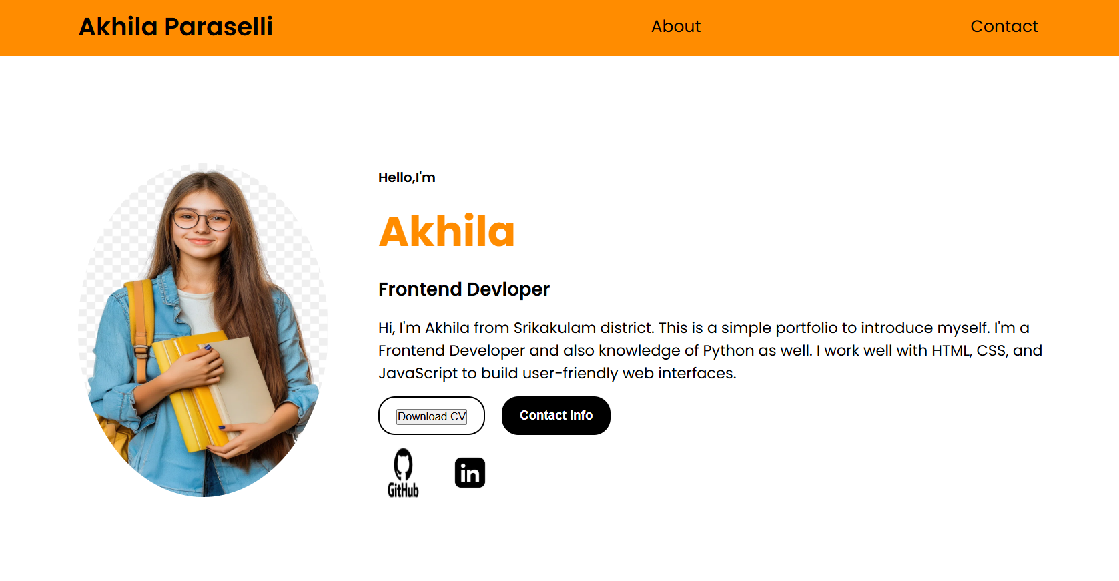

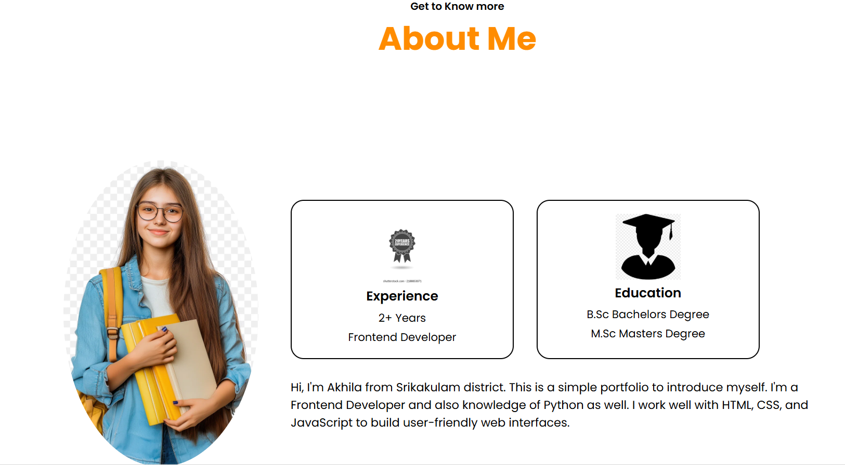

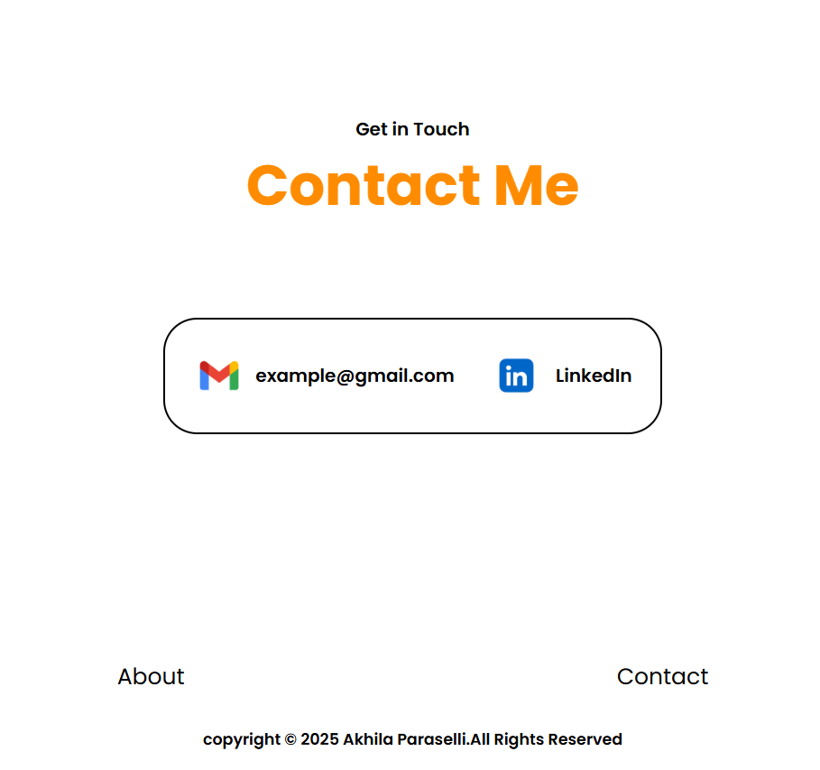

**In mobile phones it will be…**

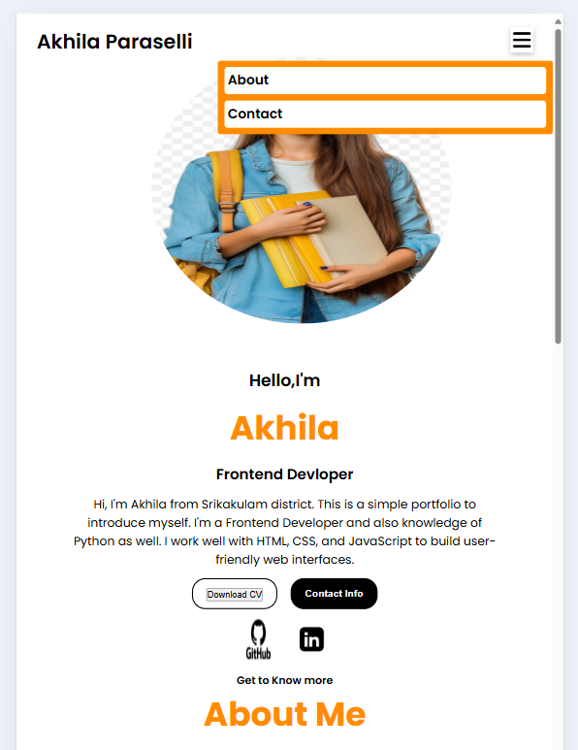 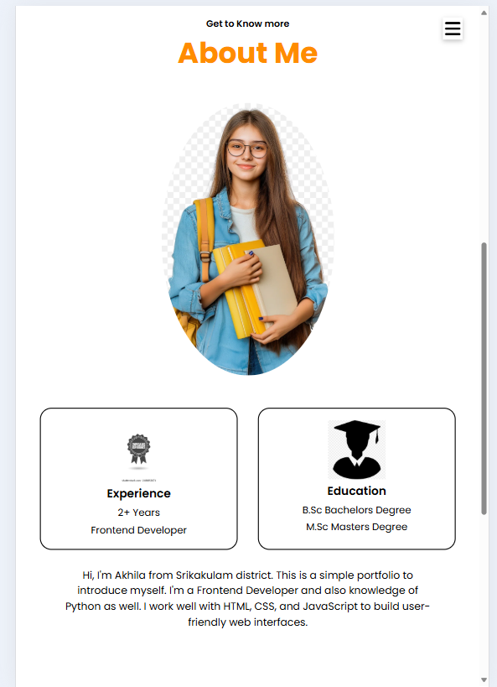

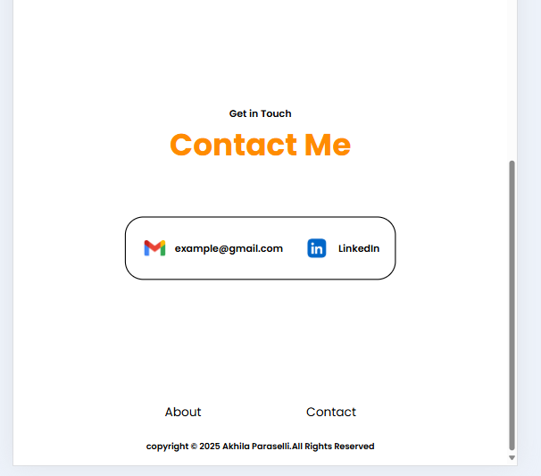

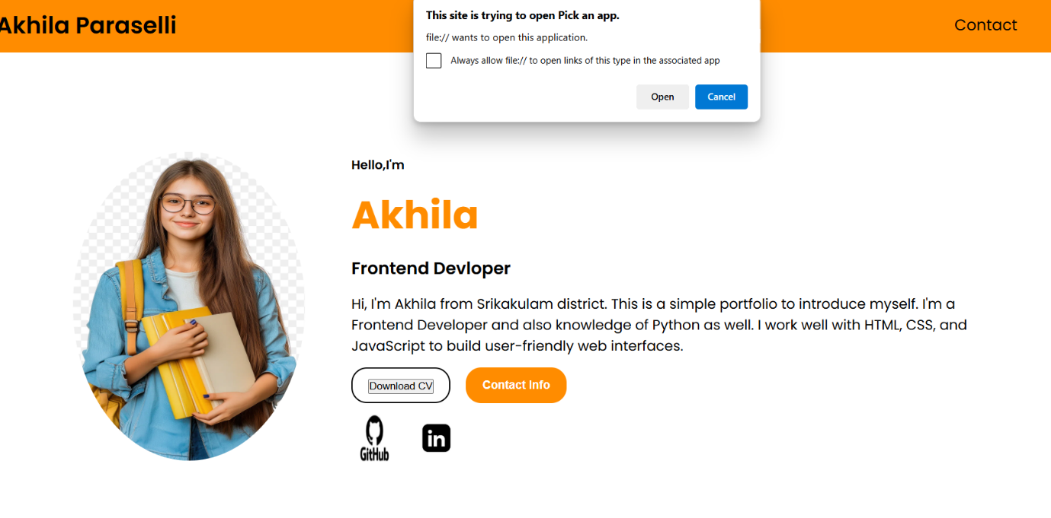

**CONCLUSION:**

This single-page portfolio website for **Akhila Paraselli** effectively showcases personal and professional information using only **HTML, CSS, and JavaScript**. It is fully responsive and includes basic interactivity suitable for a developer portfolio. The project demonstrates how clean layout, semantic HTML, and simple scripting can build a complete online presence.